- Using sources A and B, and your own knowledge, answer the question, did the Treaty of Versailles help to create world peace?
Source A | Source B
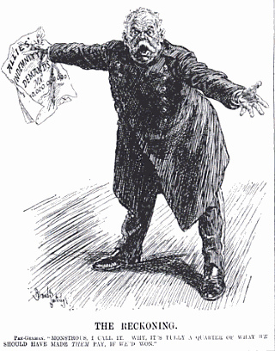 | 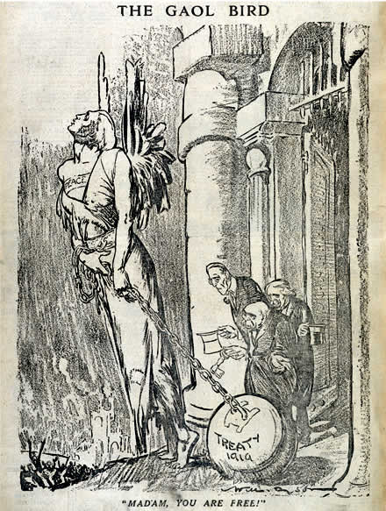
- When was the first meeting of the Paris Peace Conference?
  - 18th January 1919
  - 11th November 1918
  - 11th November 1919
  - 28th June 1919
  - 8th January 1919
- Which of these leaders wanted nations to be divided by race rather than Empire?
  - David Lloyd George
  - Woodrow Wilson
  - Vittorio Orlando
  - Georges Clemenceau
  - Hara Takashi
- How many points of peace did Woodrow Wilson have?
  - 12
  - 10
  - 15
  - 14
  - 16
- Which country wanted Germany to be punished the most?
  - Great Britain
  - France
  - America
  - Italy
  - Japan
- What was the bill set for reparations to be paid by Germany in the Treaty of Versailles?
  - £6600 million
  - No amount was set
  - US $5 million
  - £10 billion
  - £21 billion

